

**Green University of Bangladesh**

**Department of Computer Science & Engineering**

**Project Name: Cineplex Management System**

**Course Code: CSE-210 Course Title: Database System Lab**

**Course Teacher:** MS. BABE SULTANA

Lecturer

Dept. of CSE

Sec: DA

**Group Members**

|  |  |
| --- | --- |
| Name | ID |
| Md. Shammir Ahmed | 191002271 |
| Shahriar Rahman Evan | 191002298 |
| Taslima Akter | 191002043 |

19 |

P a g

19 |

P a g

**List of Contents:**

1. Scenario:
2. ER Diagram:
3. NORMALIZATION:
4. Table Creation with screenshots
5. Data insertion:
6. Joining:
7. Query Writing on the tables:
8. Group Function
9. View

10.Using limit (ORDER BY, ASC, DESC)

11.Trigger

**Scenario:**

Star Cineplex is the first multiplex cinema theatre in Bangladesh.Star Cineplex has a strong management for maintaining the whole system. A Manager has M_ID, M_name, M_address, M_phone, M_email. In Cineplex management system there are many employees who controlled by the manager. The attributes of employees include E_ID, E_name, E_address, E_phone, E_mail, E_salary, E_age.Manager manages all employees. Tickets is must needed for watching a show in cineplex. Few employees sell ticket in ticket booth or people can buy tickets from online by visiting cineplex official website. A Ticket has T_ID, T_name, T_price. One ticket can be sold from only one show. Show has some attributes include S_id,S_name, S_date, Start_ time, End _time. One show will run at a time. One manager can manage many employees.

**ER Diagram:**

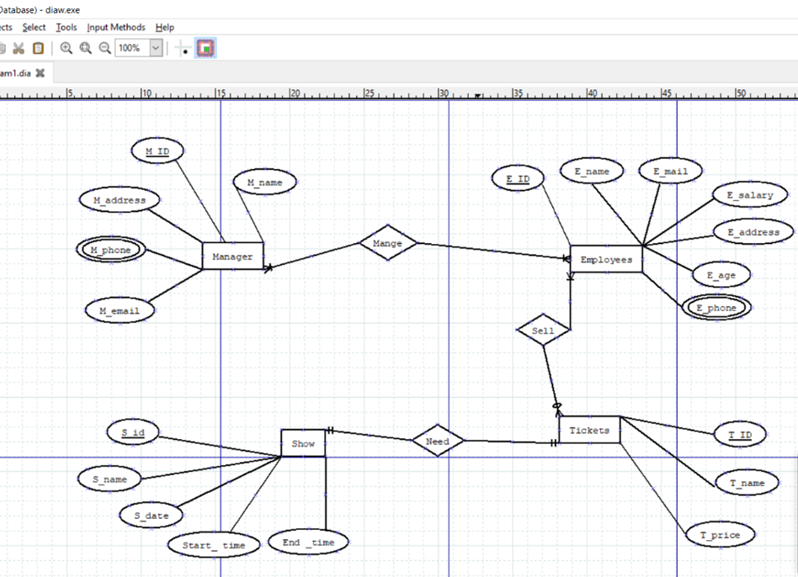

**NORMALIZATION:**

Manage (M_id,M_name,M_address,M_phone,M_email,E_id,E_name,E_mail,E_salary,E_address,

E_age,E_phone)

**1NF:**

M_phone & E_phone -> multivalued attributes

**2NF:**

M_ID, M_name, M_address,M_phone,M_email

E_id, E_name,E_mail,E_salary,E_address,E_age,E_phone

**3NF:**

M_ID, M_name,M_address,M_phone,M_email

E_id ,E_name,E_mail,E_salary,E_address,E_age,E_phone

No transitive dependency.

**Table:**

M_ID,M_name,M_address,M_phone,M_email

E_id,E_name,E_mail,E_salary,E_address,E_age,E_phone

Sell (E_id,E_name,E_mail,E_salary,E_address,E_age,E_phone,T_id,T_name,T_price)

**1NF:**

E_phone -> multivalued attribute.

**2NF:**

E_id,E_name,E_mail,E_salary,E_address,E_age,E_phone

T_id,T_name,T_price

**3NF:**

E_id,E_name,E_mail,E_salary,E_address,E_age,E_phone

T_id,T_name,T_price

No transitive dependency.

Table:

E_id,E_name,E_mail,E_salary,E_address,E_age,E_phone

T_id,T_name,T_price

Need (T_id,T_name,T_price,S_id,S_name,Start_time,End_time)

**1NF:**

No multivalued attributes

**2NF:**

T_id,T_name,T_price,S_id

S_id,S_name,Start_time,End_time

**3NF:**

T_id,T_name,T_price,S_id

S_id,S_name,Start_time,End_time

No transitive dependency

Table:

T_id,T_name,T_price,S_id

S_id,S_name,Start_time,End_time

Total Table:

M_ID,M_name,M_address,M_phone,M_email

E_id,E_name,E_mail,E_salary,E_address,E_age,E_phone

~~E_id,E_name,E_mail,E_salary,E_address,E_age,E_phone~~

T_id,T_name,T_price

T_id,T_name,T_price,S_id

S_id,S_name,Start_time,End_time

Final Table:

1st. M_ID,M_name,M_address,M_phone,M_email

2nd. E_id,E_name,E_mail,E_salary,E_address,E_age,E_phone

3rd. T_id,T_name,T_price

4th. T_id,T_name,T_price,S_id

5th. S_id,S_name,Start_time,End_time

**Table Creation with screenshots:**

Create table Manager (M_id int Primary key,M_name varchar(25) not null,M_address varchar(35) not null,M_phone int unique,M_email varchar(20) unique);

Desc manager

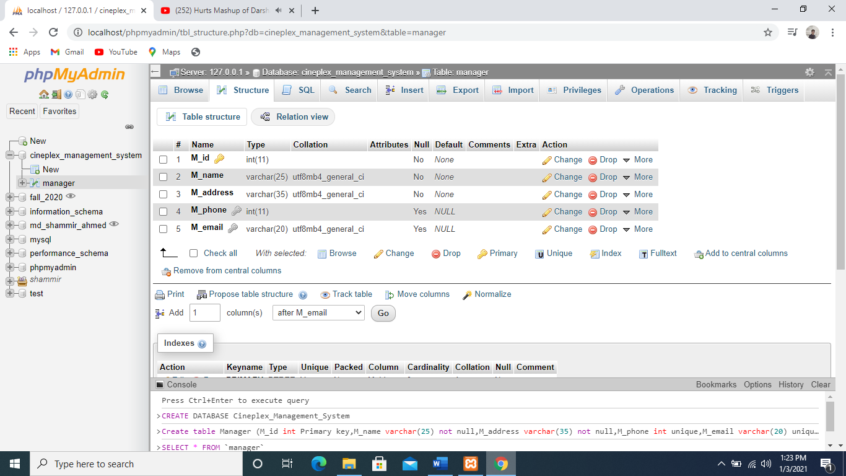

Create Table Employee(E_id int primary key,E_name varchar(25) default 'No name',E_email varchar(20) unique,E_salary int check (E_salary>0),E_address varchar(35) not null,E_age int check (E_age>16),E_phone int unique);

Desc Employee

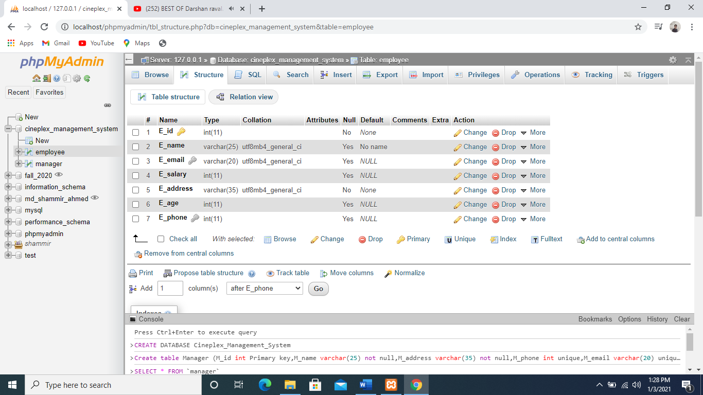

Create table Tickets(T_id int primary key,T_name varchar(15) default 'No name',T_price int check (T_price>300));

Desc Tickets

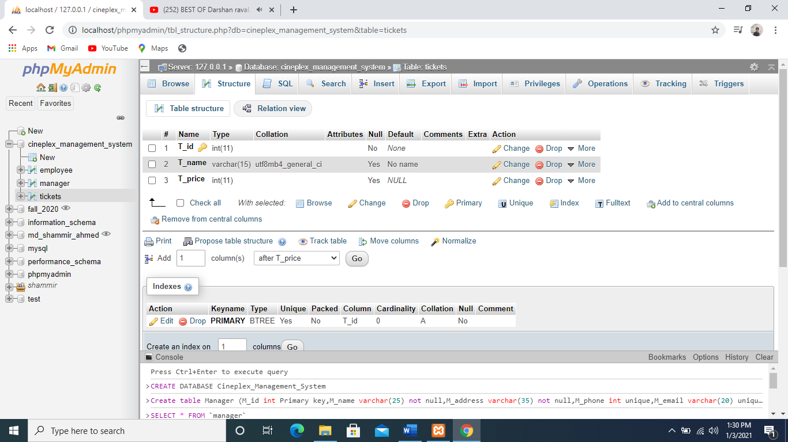

Create Table Shows(S_id int primary key,S_name varchar(15) default 'No name',Start_time varchar(6) not null,End_time Varchar(6) not null);

Desc Shows

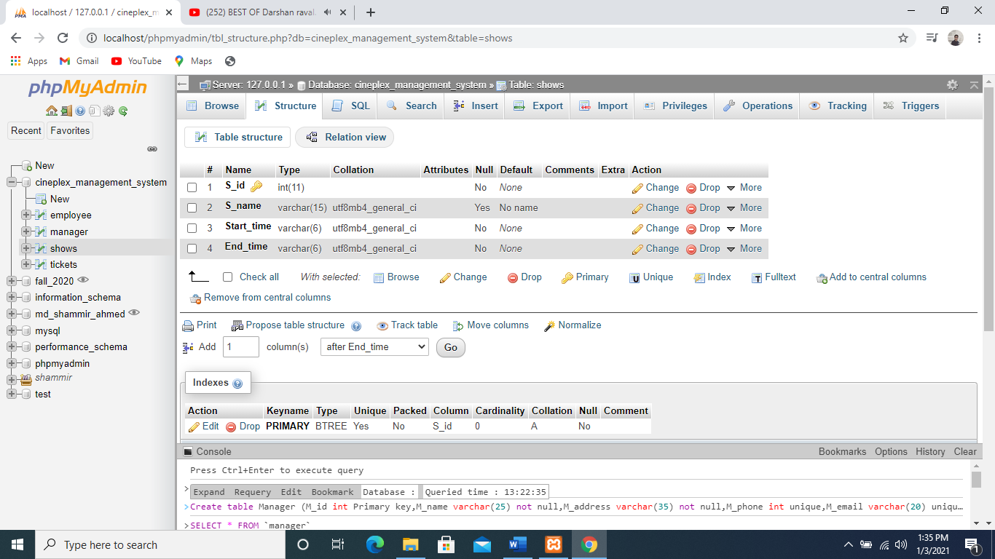

Create table Ticket_show(T_id int primary key,T_name varchar(15) default 'No name',T_price int check (T_price>300),S_id int ,CONSTRAINT fk_S_id

FOREIGN KEY (S_id)

REFERENCES SHows(S_id));

Desc Ticket_show

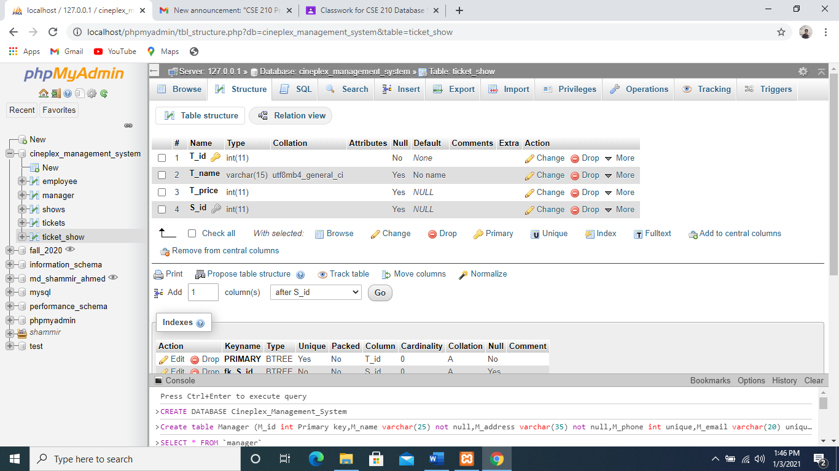

**Data insertion:**

For Manager Table:

Insert into Manager(M_id,M_name,M_address,M_phone,M_email)values(1,'Rahman

Hasan','Mirpur-10,Dhaka',117262589,'rhasan@gmail.com');

Insert into Manager(M_id,M_name,M_address,M_phone,M_email)values(2,'Kabir

Hasan','Mirpur-2,Dhaka',113456589,'khasan@gmail.com');

Insert into Manager(M_id,M_name,M_address,M_phone,M_email)values(3,'Anik

Paul','Nikunja-2,khilkhet',517002389,'anikp@gmail.com');

Insert into Manager(M_id,M_name,M_address,M_phone,M_email)values(4,'Ashik

Rahman','Mirpur-1,Dhaka',419354729,'ashik695@gmail.com');

Insert into Manager(M_id,M_name,M_address,M_phone,M_email)values(5,'Shawon

Zaman','Nikunja-2,khilkhet',616219424,'szaman@gmail.com');

Insert into Manager(M_id,M_name,M_address,M_phone,M_email)values(6,'Chisty

Nomanuzzaman','kuratoli,Dhaka',280981723,'chisty767@gmail.com');

Insert into Manager(M_id,M_name,M_address,M_phone,M_email)values(7,'Emtiaz

Anik','Kuratoli,Dhaka',029176589,'anik876@yahoo.com');

Insert into Manager(M_id,M_name,M_address,M_phone,M_email)values(8,'Ahmed

Awsaf','Mirpur-10,Dhaka',098276523,'awsaf897@gmail.com');

Insert into Manager(M_id,M_name,M_address,M_phone,M_email)values(9,'Ashesh

Talukdar','Rampura,Dhaka',093672938,'ashesh676@gmail.com');

Insert into Manager(M_id,M_name,M_address,M_phone,M_email)values(10,'Murad

Elahi','Kuratoli,Dhaka',039721538,'murad667@gmail.com');

select *from manager

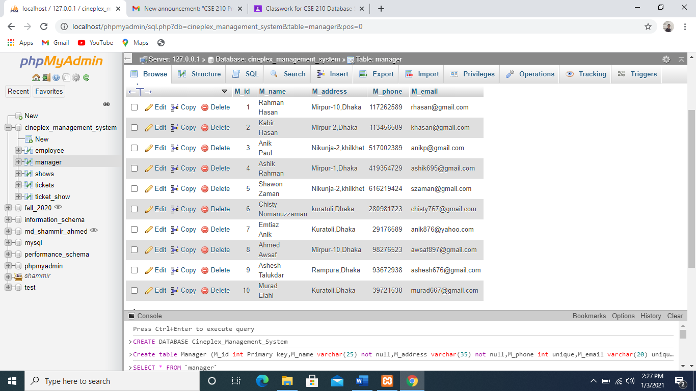

For Employee Table:

Insert into Employee(E_id,E_name,E_email,E_salary,E_address,E_age,E_phone)Values(101,'Asif',

'asif898@gmail.com',4500,'Mirpur-2,Dhaka',17,0928238121);

Insert into Employee(E_id,E_name,E_email,E_salary,E_address,E_age,E_phone)Values(102,'Rakib',

'rakib3452@gmail.com',4500,'Nilkhelt,Dhaka',18,092873615);

Insert into Employee(E_id,E_name,E_email,E_salary,E_address,E_age,E_phone)Values(103,'Sakib',

'sakib66@yahoo.com',4200,'Panthapoth,Dhaka',20,093275634);

Insert into Employee(E_id,E_name,E_email,E_salary,E_address,E_age,E_phone)Values(104,'Jisan',

'jissan33@gmail.com',4000,'Gulsan,Dhaka',22,391231024);

Insert into Employee(E_id,E_name,E_email,E_salary,E_address,E_age,E_phone)Values(105,'Rakin',

'rakin27@gmail.com',5000,'Bananni,Dhaka',17,0391827652);

Insert into Employee(E_id,E_name,E_email,E_salary,E_address,E_age,E_phone)Values(106,'Turjo',

'turjo44@gmail.com',4800,'Kuratoli,Dhka',18,051234520);

Insert into Employee(E_id,E_name,E_email,E_salary,E_address,E_age,E_phone)Values(107,'Rouf',

'rouf78@gmail.com',3500,'Mirpur,Dhaka',24,0412783102);

Insert into Employee(E_id,E_name,E_email,E_salary,E_address,E_age,E_phone)Values(108,'Tutol',

'tutol44@gmail.com',4800,'Zatrabari,Dhaka',20,021234192);

Insert into Employee(E_id,E_name,E_email,E_salary,E_address,E_age,E_phone)Values(109,'Shuvro',

'shu44@gmail.com',4700,'Bananni,Dhaka',20,192031234);

Insert into Employee(E_id,E_name,E_email,E_salary,E_address,E_age,E_phone)Values(110,'Rifat',

'rifat99@gmail.com',5000,'Mirpur,Dhaka',22,091837212);

select *from employee

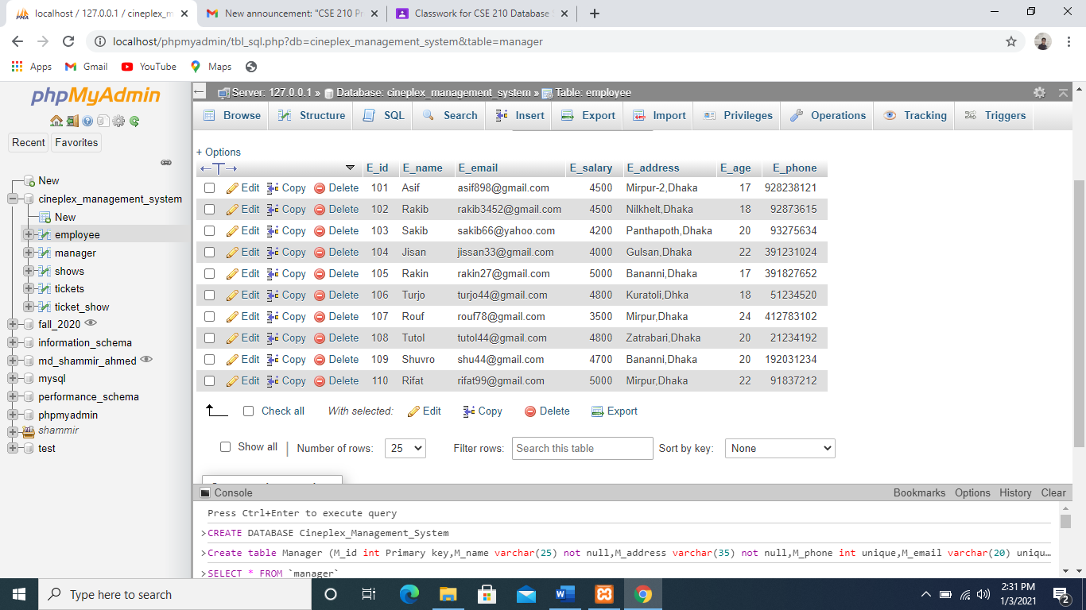

For Tickets Table:

Insert into Tickets(T_id,T_name,T_price)values(0001,'General',320);

Insert into Tickets(T_id,T_name,T_price)values(0002,'VIP',500);

Insert into Tickets(T_id,T_name,T_price)values(0003,'PREMIUM',400);

Insert into Tickets(T_id,T_name,T_price)values(0004,'General',320);

Insert into Tickets(T_id,T_name,T_price)values(0005,'PREMIUM',400);

Insert into Tickets(T_id,T_name,T_price)values(0006,'General',320);

Insert into Tickets(T_id,T_name,T_price)values(0007,'VIP',500);

Insert into Tickets(T_id,T_name,T_price)values(0008,'PREMIUM',400);

Insert into Tickets(T_id,T_name,T_price)values(0009,'PREMIUM',400);

Insert into Tickets(T_id,T_name,T_price)values(0010,'VIP',500);

Select *from Tickets

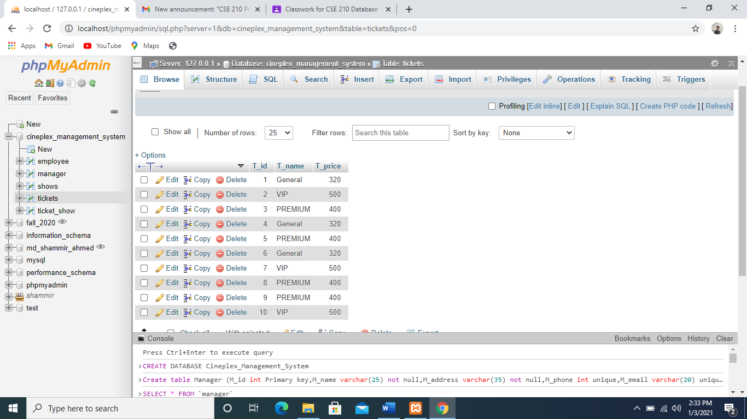

For Shows Table:

Insert into Shows(S_ID,S_Name,Start_time,End_time)Values(01,'Movie 1','9 am','10 am');

Insert into Shows(S_ID,S_Name,Start_time,End_time)Values(02,'Movie 2','10 am','11 am');

Insert into Shows(S_ID,S_Name,Start_time,End_time)Values(03,'Movie 3','11 am','12 pm');

Insert into Shows(S_ID,S_Name,Start_time,End_time)Values(04,'Movie 4','12 pm','1 pm');

Insert into Shows(S_ID,S_Name,Start_time,End_time)Values(05,'Movie 5','1 pm','2 pm');

Insert into Shows(S_ID,S_Name,Start_time,End_time)Values(06,'Movie 1','3 pm','4 pm');

Insert into Shows(S_ID,S_Name,Start_time,End_time)Values(07,'Movie 3','4 pm','5 pm');

Insert into Shows(S_ID,S_Name,Start_time,End_time)Values(08,'Movie 4','5 pm','6 pm');

Insert into Shows(S_ID,S_Name,Start_time,End_time)Values(09,'Movie 2','6 pm','7 pm');

Insert into Shows(S_ID,S_Name,Start_time,End_time)Values(10,'Movie 5','7 pm','8 pm');

Select *from Shows

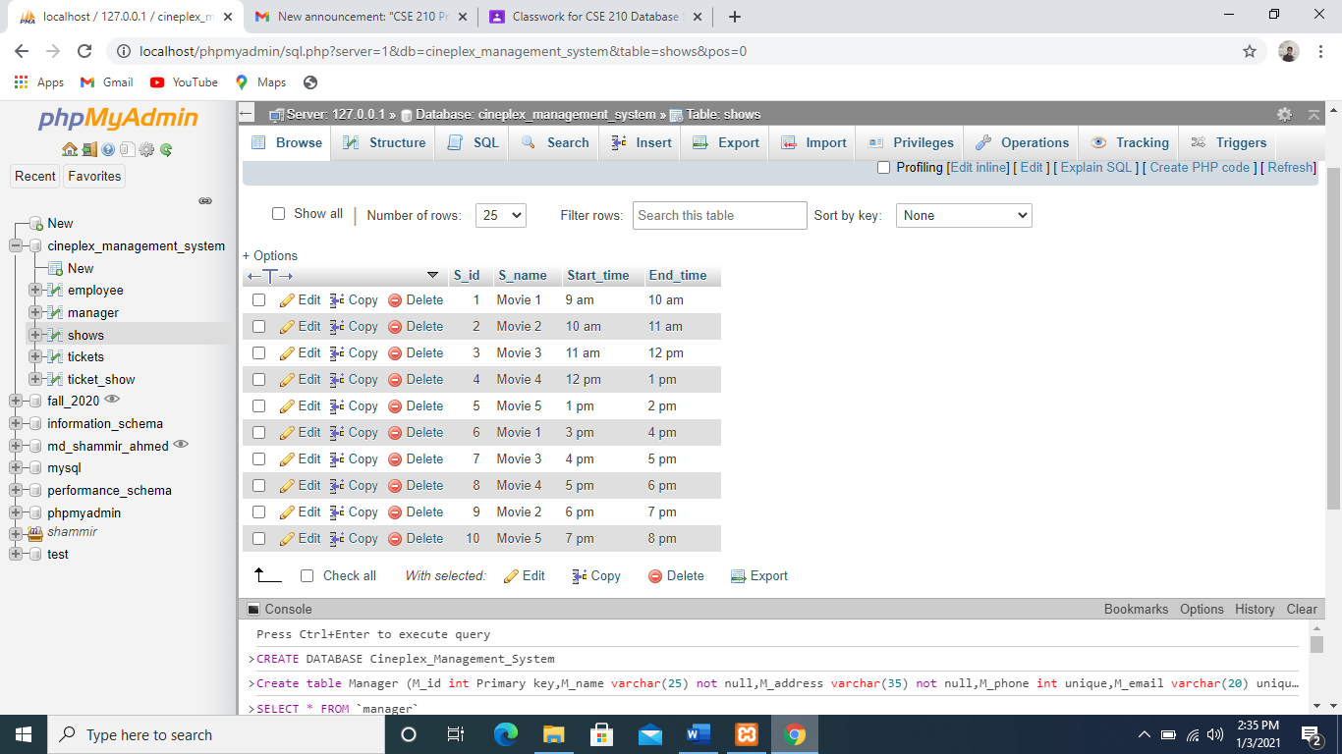

For Ticket_Show Table:

Insert into Ticket_show(T_id,T_name,T_price,S_id)Values(0001,'General',320,01);

Insert into Ticket_show(T_id,T_name,T_price,S_id)Values(0002,'VIP',500,02);

Insert into Ticket_show(T_id,T_name,T_price,S_id)Values(0003,'PREMIUM',400,03);

Insert into Ticket_show(T_id,T_name,T_price,S_id)Values(0004,'General',320,04);

Insert into Ticket_show(T_id,T_name,T_price,S_id)Values(0005,'PREMIUM',400,05);

Insert into Ticket_show(T_id,T_name,T_price,S_id)Values(0006,'General',320,06);

Insert into Ticket_show(T_id,T_name,T_price,S_id)Values(0007,'VIP',500,07);

Insert into Ticket_show(T_id,T_name,T_price,S_id)Values(0008,'PREMIUM',400,08);

Insert into Ticket_show(T_id,T_name,T_price,S_id)Values(0009,'PREMIUM',400,09);

Insert into Ticket_show(T_id,T_name,T_price,S_id)Values(0010,'VIP',500,10);

Select *from Ticket_show

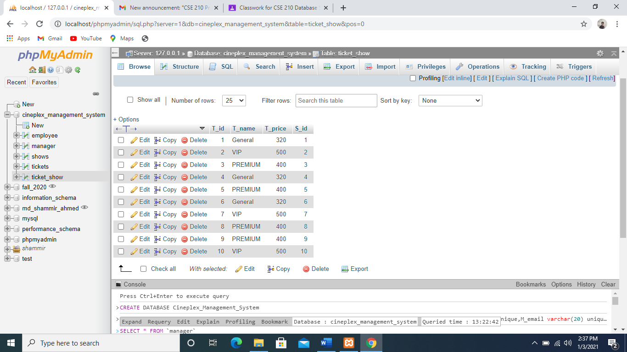

**Joining:**

1.Write a query to display Shows name,Start and end time ,Tickets for shows price and name when there Shows number is 4.(Equi-join)

🡪 Select S.S_name,S.Start_time,S.End_time,T.T_name,T.T_price from Shows as S,Ticket_show as T where S.S_id=T.T_iD and S.S_id=4

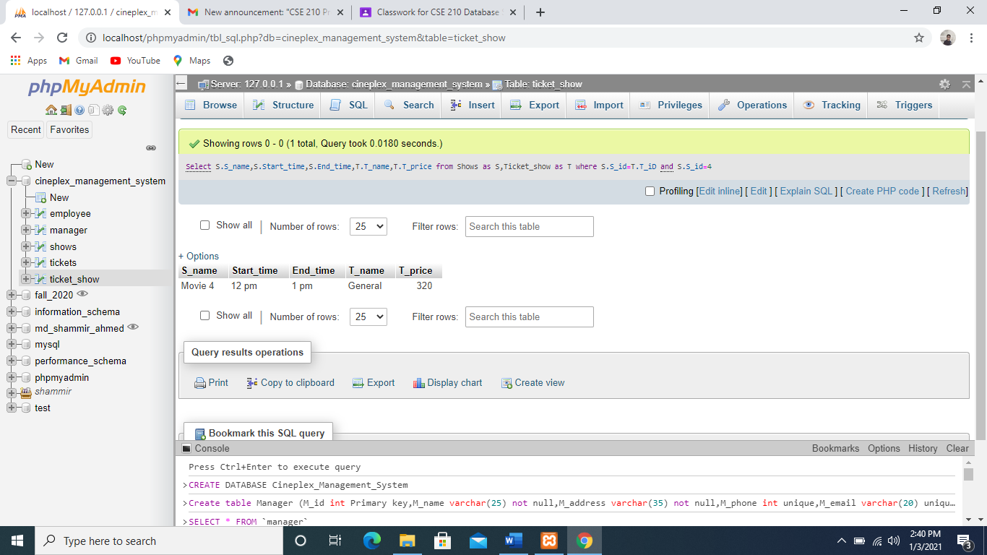

2.Write a query to display Shows name and tickets shows price and name. (Equi-join)

🡪 Select S.S_name,T.T_name,T.T_price from Shows as S,Ticket_show as T where S.S_id=T.T_iD;

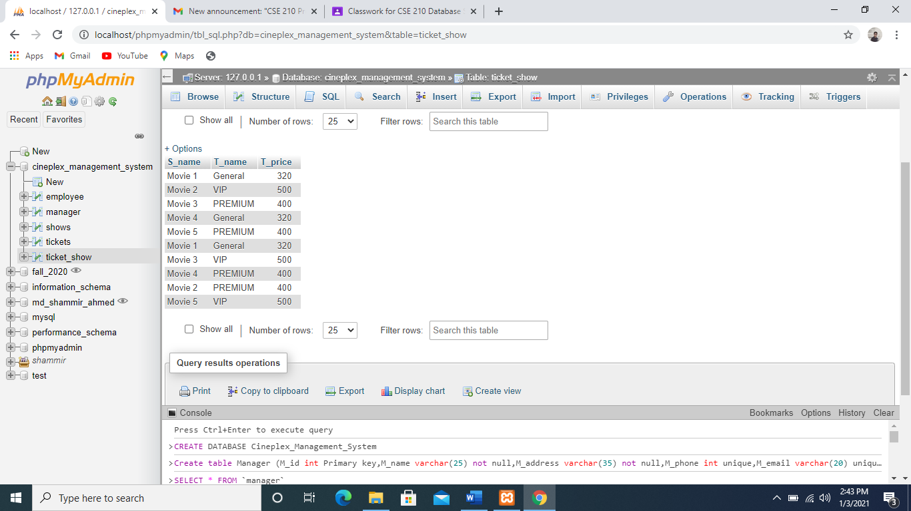

3.Write a query to display shows name id, end time and start time and tickets name and prices using outer join

🡪 Select S.S_name,S.Start_time,S.End_time,T.T_name,T.T_price from Shows as S,Ticket_show as T where S.S_id=T.S_id;

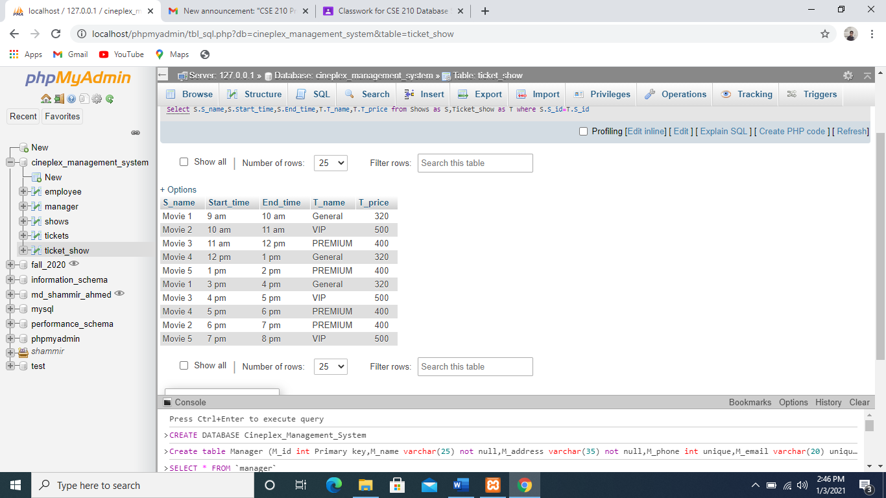

4.Write a query to display _______Tickets price is _______ using CONCAT function & join & GROUP by.

🡪 Select CONCAT(T.T_name, ' Ticket price is ',T.T_price) from Ticket_show T,Ticket_show s GROUP by T.T_name;

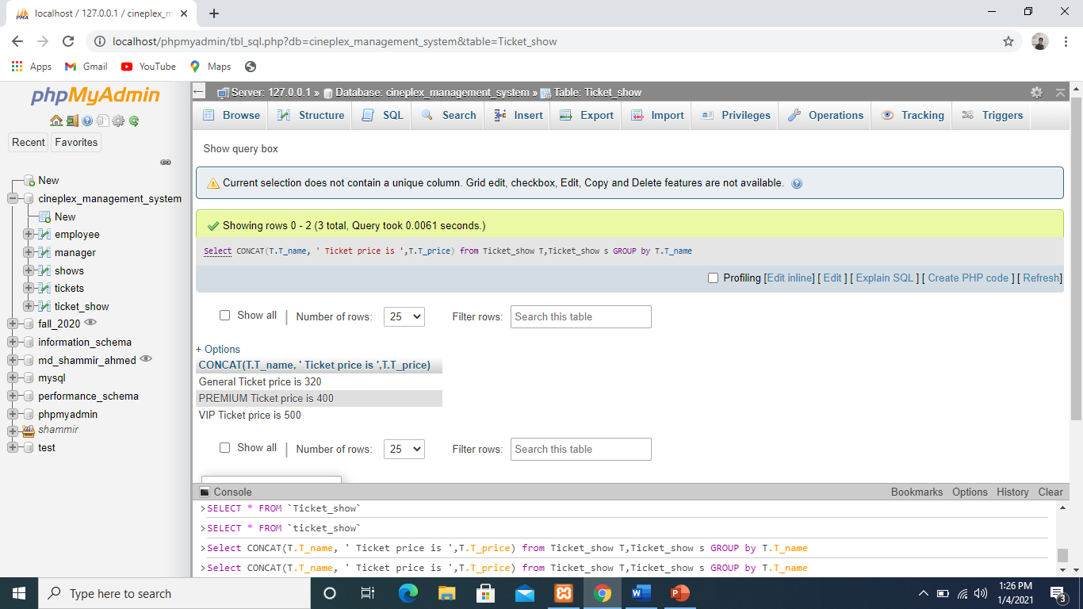

**Query Writing on the tables:**

Subquery-

1.Write a query to display Ticket name where ticket id is greater than 5. (Tickets table)

🡪Select T_name from Tickets where T_Id > (Select T_Id from Tickets where T_Id=5);

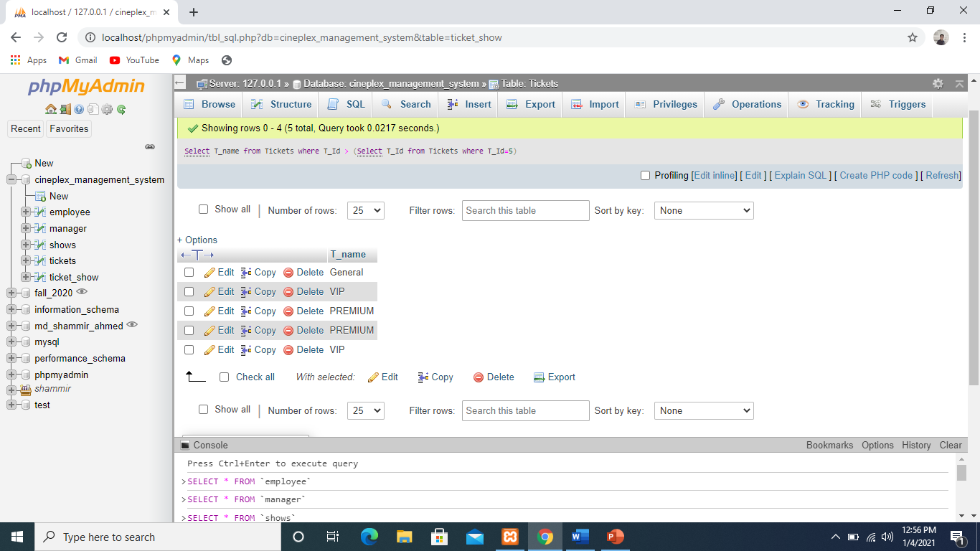

2. Write a query to display the Ticket id, Ticket name and Ticket price for all Tickets whose price more or equal than the average price. (Tickets table)

🡪Select T_ID,T_NAME,T_Price from Tickets where T_price >= (select avg(T_price) from Tickets);

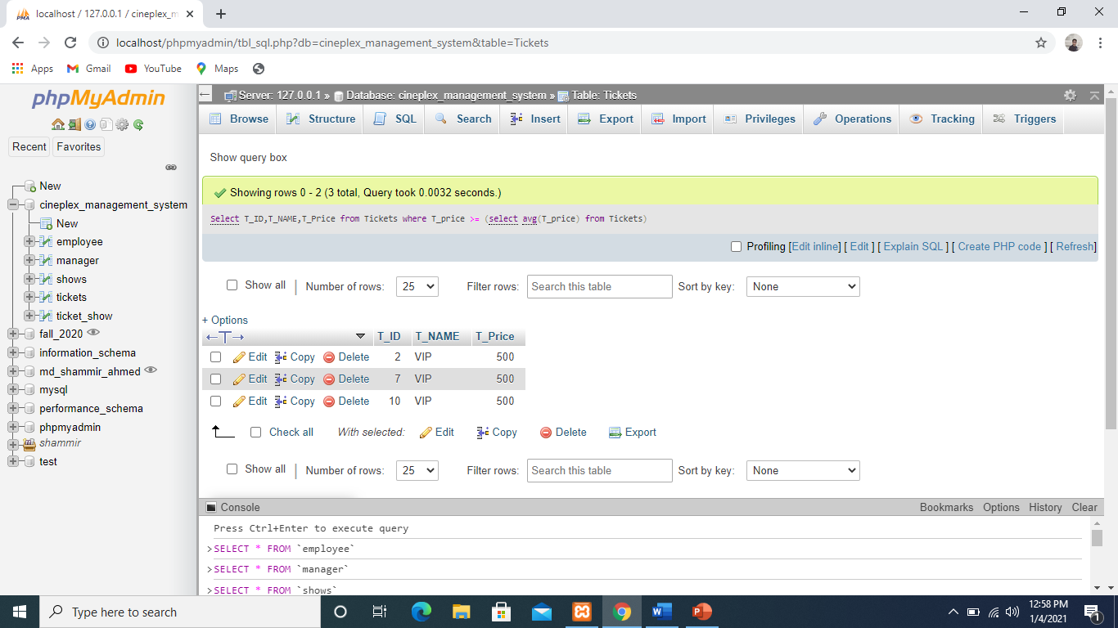

3.Write a query to display Employees name,salary and age who get the age wise lowest salary.(Employee Table)

🡪Select E_name,E_salary,E_Age from employee where E_salary in(Select min(E_Salary) from employee group by E_Age );

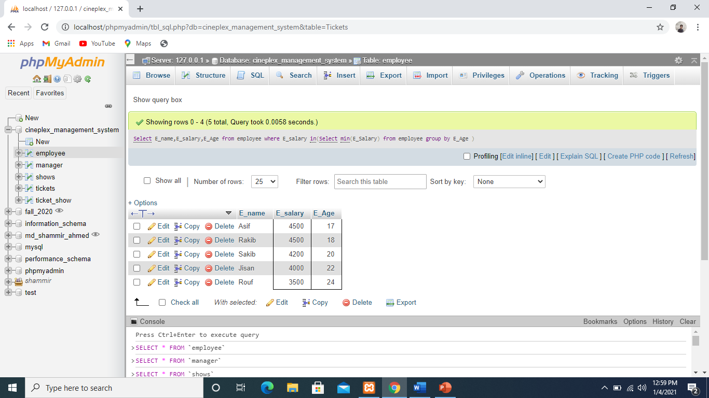

**Group Function:**

1.Write a query to display average, maximum, minimum and sum of all employees salary.(employee table)

🡪Select avg(E_salary),max(E_salary),min(E_salary),sum(E_salary) from employee;

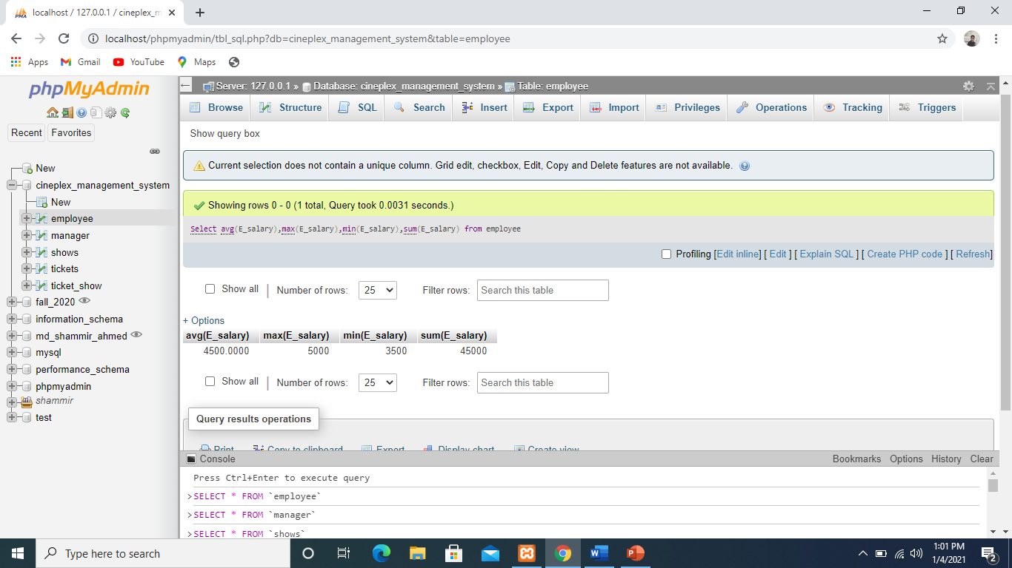

2.Find out Avg employees salary and max salary whose age is 20 and round that avg salary make its name AVG. (Employee table)

🡪Select Round(avg(E_salary),2) as AVG,Max(E_Salary) from employee where E_age=20;

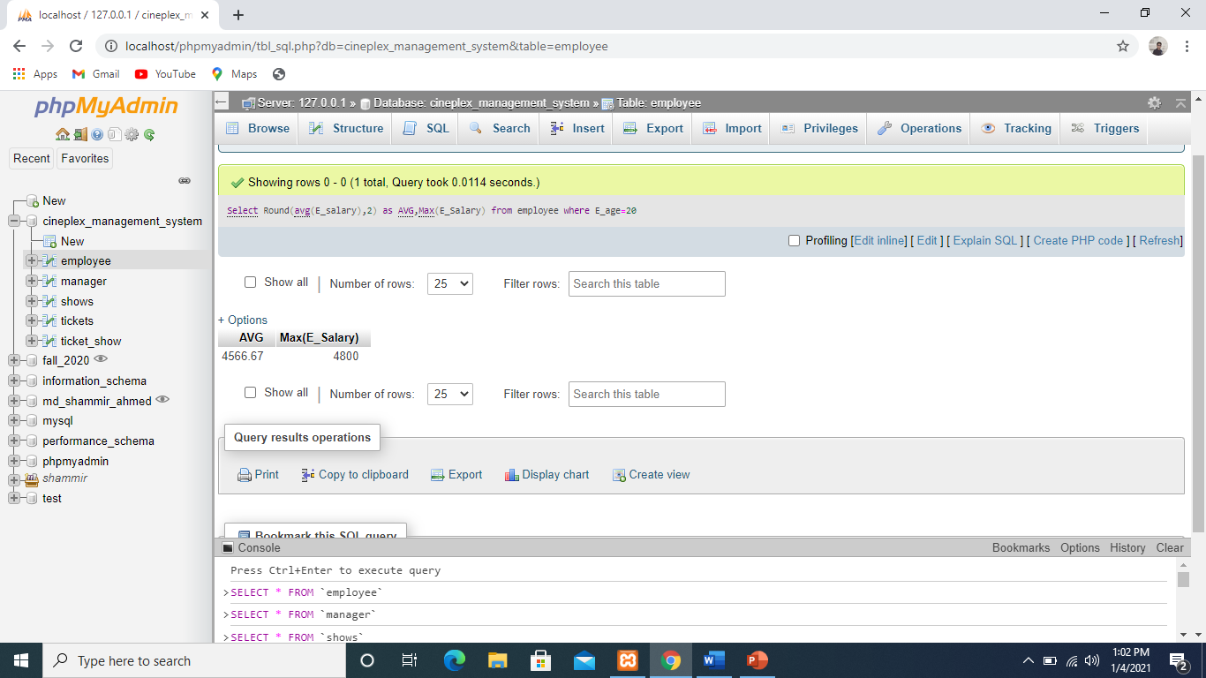

3.Write a query to display max tickets price ,name and group by tickets name.(Tickets Table)

🡪Select Max(T_price),T_name from Tickets group by T_name

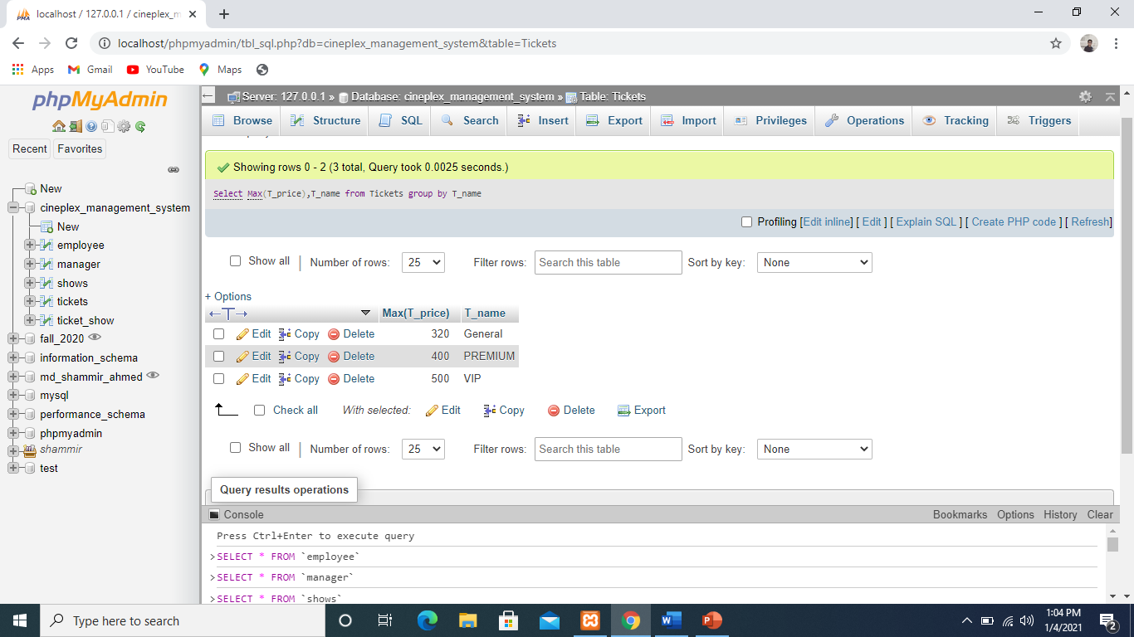

**View:**

1.Create a view name Home_Mirpur where there will be managers name,address,phone number and mangers name at least contain Mirpur.(Manager Table)

🡪 select M_name,M_Address,M_phone from manager where M_address like 'Mirpur%';

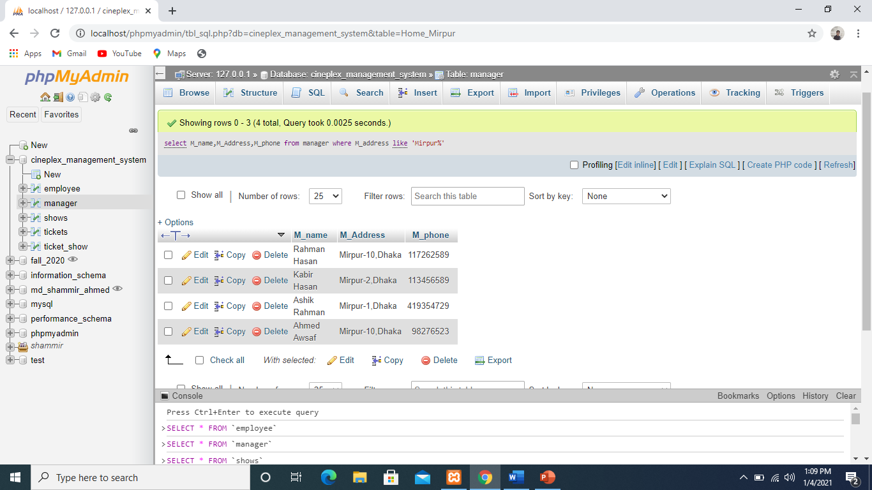

2.Create a view name Sun_details where there will be show name, show start, ticket name, ticket price where show id=ticket show id.

🡪 Select S.s_name,S.Start_time,T.T_name,T.t_price from shows as S,Ticket_Show as T where S.S_id=T.S_ID;

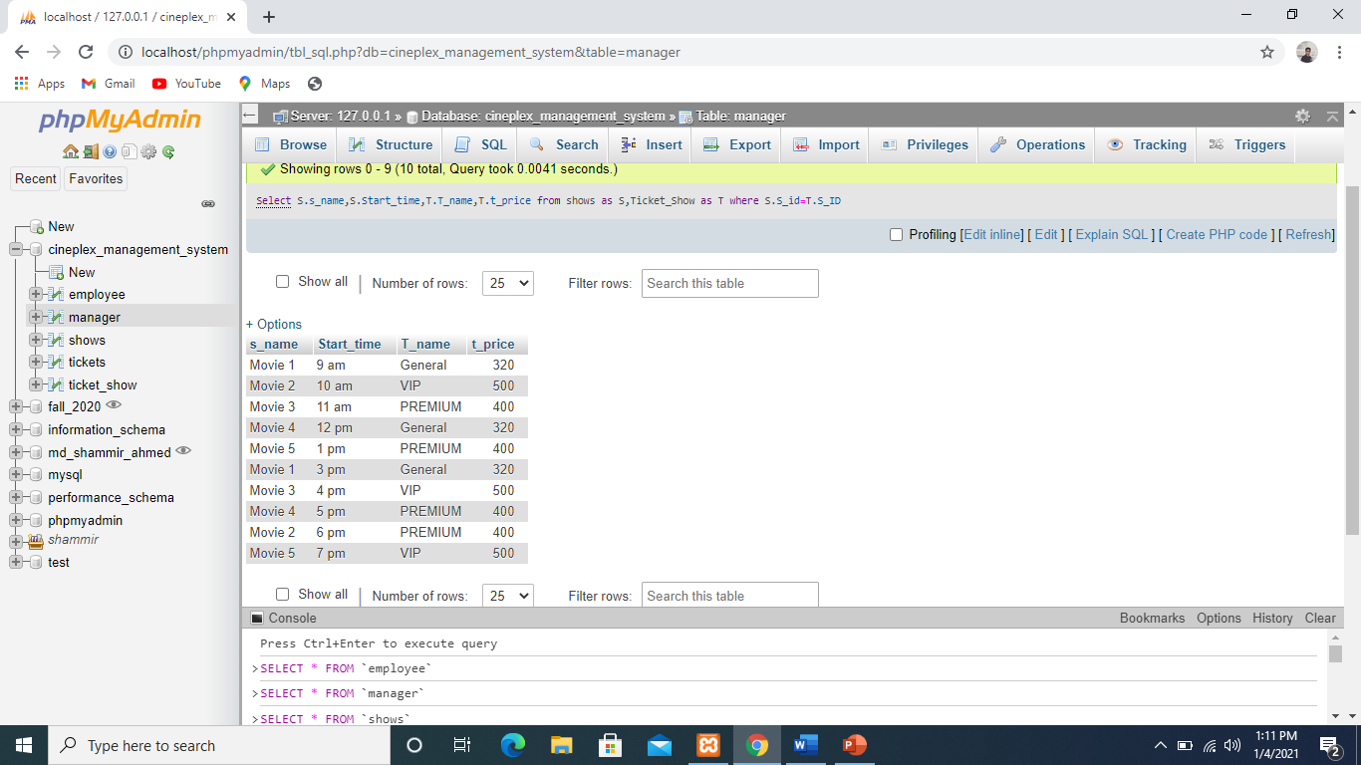

**Using limit (ORDER BY, ASC, DESC)**

1.Select the first 3 Employee.

🡪SELECT * FROM employee LIMIT 3;

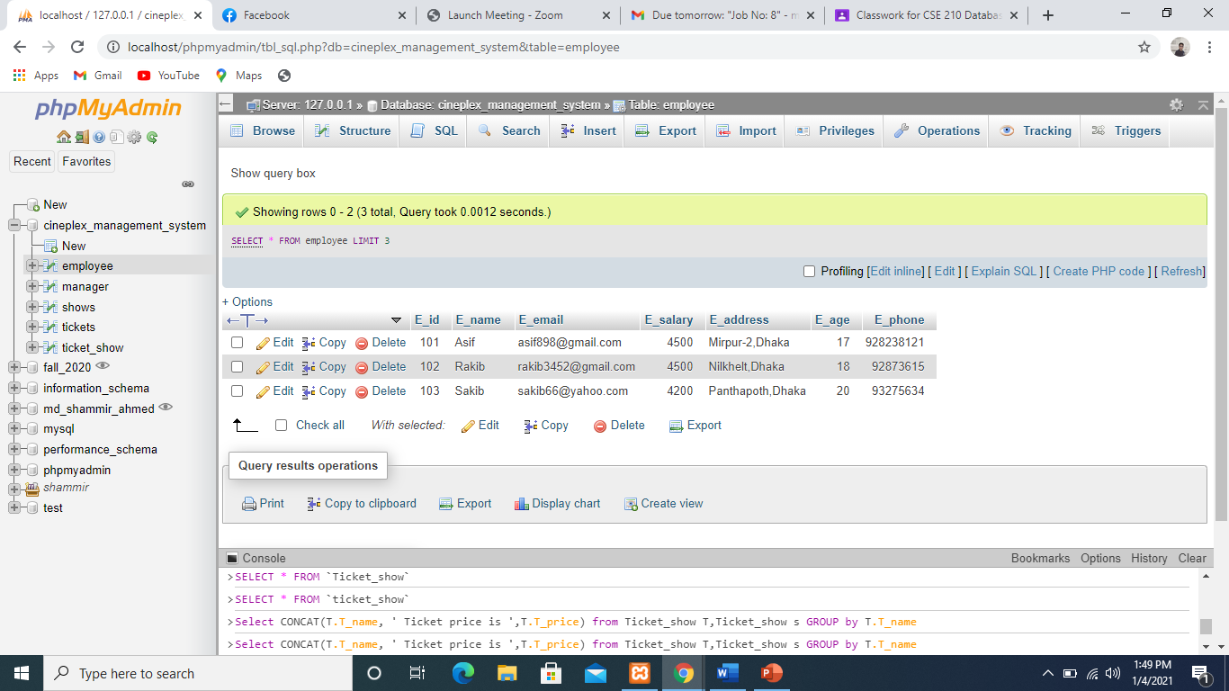

2.Select the 2nd 3 Employee.

🡪SELECT * FROM employee LIMIT 1,3;

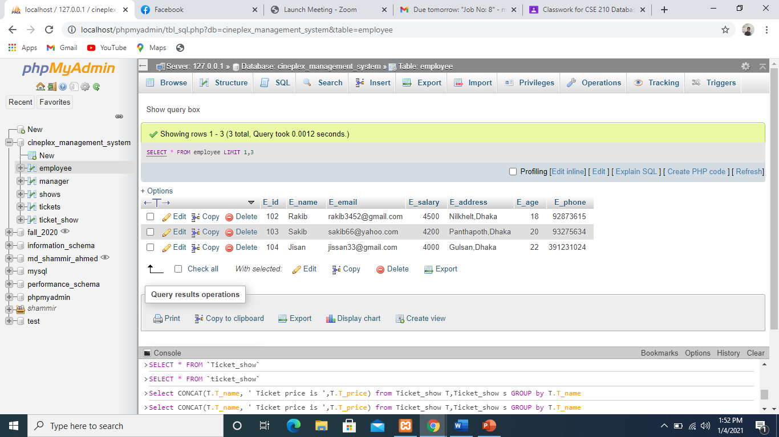

3. Using MySQL LIMIT to get the highest 3 values

🡪SELECT E_name ,E_salary FROM employee ORDER by E_salary DESC LIMIT 1,3;

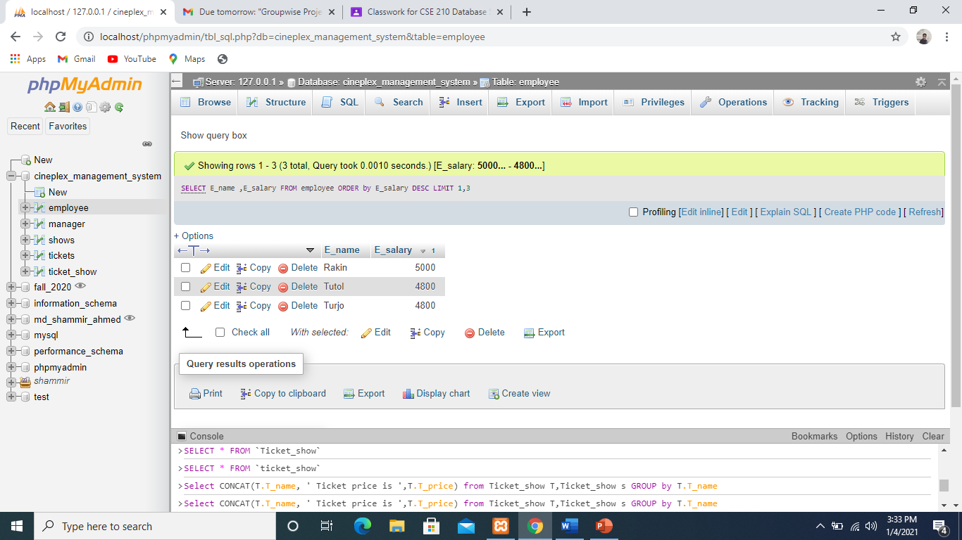

**Trigger**

1.If a employee he/she Bonus salary in a year: salary’s 50%

i) ALTER TABLE employee

ADD COLUMN bonus_salary int;

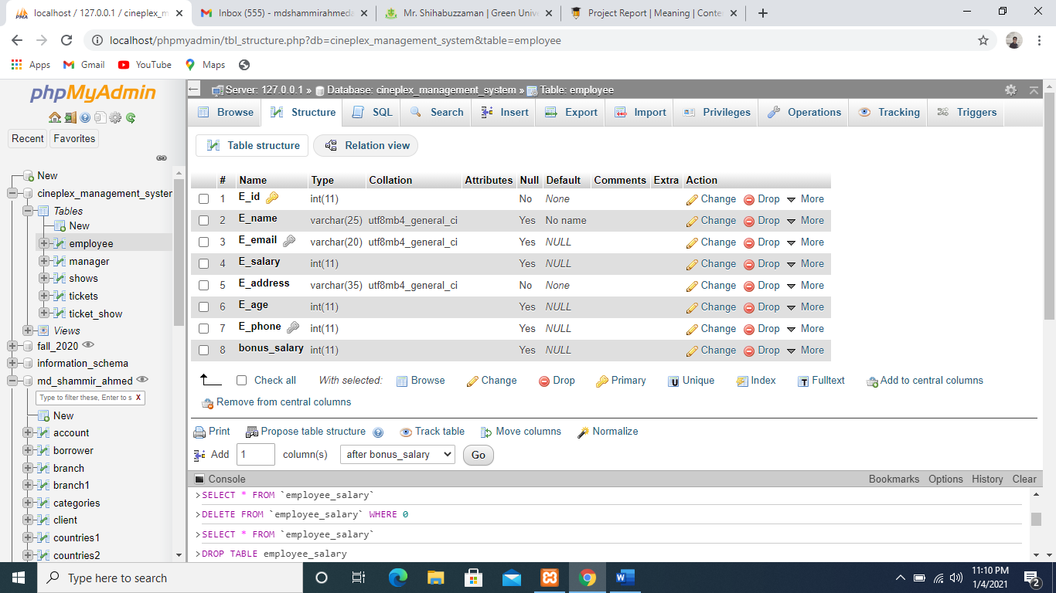

**ii)** DELIMITER $$

CREATE TRIGGER bonus_salary

BEFORE INSERT

on employee FOR EACH ROW

BEGIN

SET NEW.bonus_salary = NEW.E_salary/2;

END$$;

DELIMITER ;

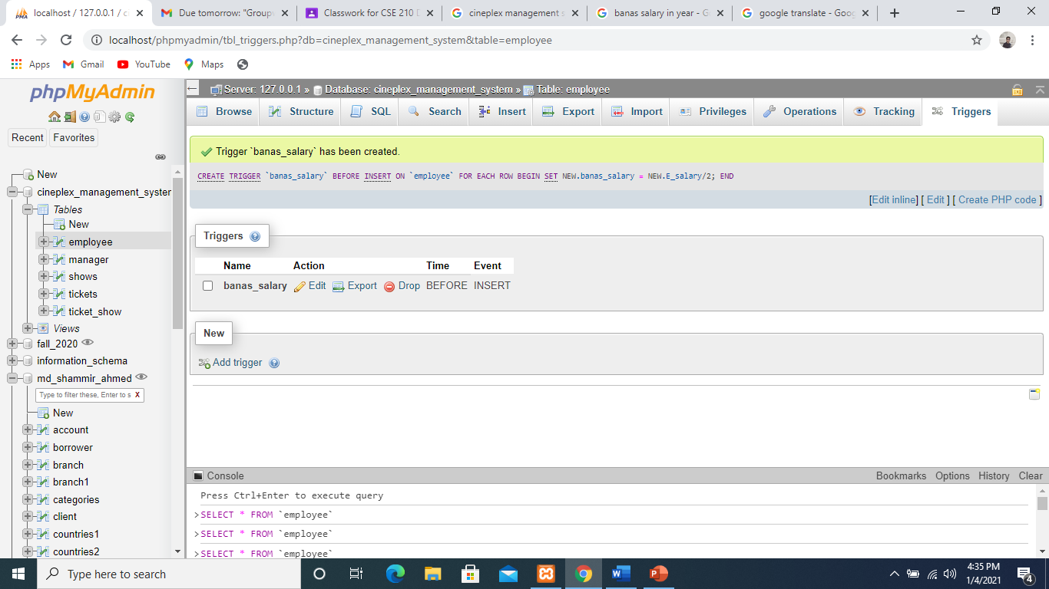

iii) select *from employee

